2024年1月第1週 高校生ニュース教材 単語テスト 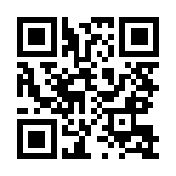
音声を聴いて、次の単語（熟語）を書きとって下さい。また、その意味を日本語で書いて下さい。
 | words/phrases | meaning
１
２
３
４
５
６
７
８
９
１０
１１
１２
１３

- genuine 本物の
- witness 目撃者
- interpret 通訳する、(このニュースでは)解釈する
- ceasefire 停戦
- theft 盗み
- anonymous 匿名の
- graffiti 落書き
- mimic 真似をしてふざける
- depict 描写・表現する
- commercialism 商業主義
- capitalism 資本主義
- terror 恐ろしさ
- insult 侮辱

Banksy’s artwork stolen in the middle of the day
１ ①A new artwork by a British street artist Banksy was stolen from a south London street on December 22nd noon. It happened just an hour after Banksy confirmed it was genuine by posting a photo on his Instagram account. The work is a red stop sign adorned with three military drones.
２ On that day, several Banksy’s fans were watching the art and taking photos. At 12:30 PM,
two men came to the street and tried to remove the sign. Witnesses said they were stunned to watch a man with bolt cutters remove the sign as another man waited with a bike. A witness said, “We said, ‘What are you doing?’ But he didn’t answer. No one knew what to do and we kept watching. He removed the artwork and ran away with another man.” The incident was captured in photos and videos.
３ Banksy is known as a mysterious and elusive artist. Many of his Instagram followers interpret the latest work as a call for a ceasefire in the Gaza strip. Banksy has criticized Israel’s violence against Palestinians. He built a hotel in Bethlehem in 2017. It is called ②the Walled Off Hotel. A similar drone art is displayed at the hotel.
４ Banksy opened the hotel to draw attention to the Israeli-Palestinian conflict. The hotel is next to the wall separating Israel and Palestine. Banksy says, ③“The hotel has the worst view in the world.”
５ London police arrested two men on suspicion of theft and criminal damage. The sign remains missing. Police are calling on the public to come forward if they know anything about the incident.
confirm確認する・裏付ける adorn装飾する be stunned唖然とする elusive捉えどころのない、神出鬼没の conflict紛争 on suspicion of～：～の容疑で come forward名乗り出る
★このニュースで覚えた語( )

Q1 What did ①a new artwork by Banksy look like?

Q2 How can we know that the work was really created by Banksy?

Q3 How did the thieves steal the artwork?

Q4 What did the witnesses do?

Q5 According to Banksy’s fans, what is the message behind the artwork?

Q6 Why did Banksy build ②the Walled Off Hotel?

Q7 What does he mean by his words: ③“The hotel has the worst view in the world”?

Q8 What happened to the two thieves that removed Banksy’s street art?

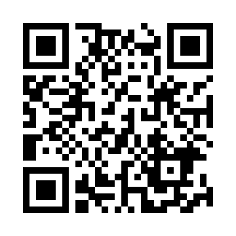 | Banksy installation taken within an hour of its creation［The Telegraph］  https://www.youtube.com/watch?v=pXiyxb9Sr5Y
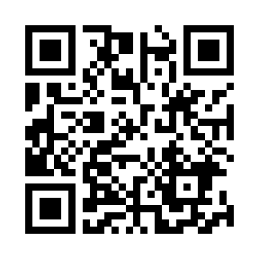 | Banksy's 'Walled Off Hotel' causes a stir in the West Bank［Euronews］  https://www.youtube.com/watch?v=IHtcy0VLa7I
Who is Banksy?
１ Banksy is an anonymous graffiti artist from the U.K. He is known for his distinctive stenciled works of art that often convey social and political messages. Banksy's artworks can be found on walls and buildings in various cities worldwide. His identity remains a mystery, often described as "elusive", "secretive" and the "guerrilla street artist".
２ Banksy is believed to have been born in Bristol in the early 1970s. He began spray-painting in the early 1990s. He rose to prominence in early 2000s after moving to London. His works became a newsworthy event, and sold for huge amounts of money.
３ In 2009, the “Banksy versus the Bristol Museum” exhibition was held at Bristol Museum. It drew huge crowds. In 2015, he organized ①“Dismaland,” a temporary art project in the seaside resort of Weston-super-Mare in England. Banksy intended to mimic and mock the attractions and characters of the Disney franchise. He later called it a “bemusement park.” ②His 2010 documentary film “Exit Through the Gift Shop” was nominated for an Academy Award. Now, let’s take a look at three of his famous artworks.
“Love is in the Air” or “Flower Thrower”
４ It was painted in 2003 in the streets of Jerusalem. It was created in response to the construction of the West Bank Wall separating Israel from Palestine, which began in 2002. Banksy says, “The West Bank Wall turns Palestine into the world’s largest open prison.”
５ The picture depicts a young man, wearing a baseball cap and a bandana, throwing a bunch of flowers. He looks angry and aggressive in his posture, but he is not throwing a bomb. He is holding flowers, the universal symbol of love and peace, the opposite item of a weapon.
distinctive特徴的な convey伝える rise to prominence有名になる newsworthy報道価値のある mock真似をしてあざわらう ★このニュースで覚えた語( )

Q1 バンクシーのアート作品の作風を説明して下さい。

Q2 Where can we find Banksy’s artworks?
Q3 For his mysterious identity, what do people often call him?

Q4 Why was his exhibition held in Bristol in 2009?
Q5 What did he try to criticize with ①Dismaland?

Q6 What did Banksy try to criticize witｈ his documentary film②？ What does the title mean?

Q7 バンクシーの絵“Love is in the Air”の中では、男性の姿勢と、彼が手に持つ物が対比されています。何が対比されているか、説明しましょう。

Q8 Where was the picture painted?
Q9 What is the message behind the picture?

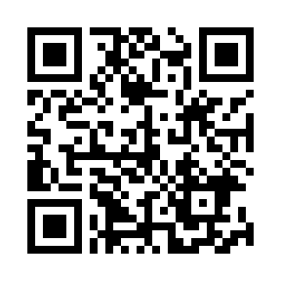 | Banksy in Bethlehem - the Flower Thrower or Love is in the Air is one of the most iconic stencils https://www.youtube.com/watch?v=svBqB2L140M
“Napalm” or “Can’t beat that Feeling”
６ It is considered to be one of Banksy's most shocking and poignant artworks. In the picture, Mickey Mouse and Ronald McDonald have captured a Vietnamese little girl, still crying, by her arms. The little girl is originally from a world-famous photograph, ④“The Terrors of War.” In the original photo, a nine-year-old girl is running away from her village attacked with a napalm blast during the Vietnam War. Despite suffering severe burns to her back, she survived the attack and now lives in Canada.
７ In Banksy’s work, the girl is in the center of two symbols of American commercialism, Micky Mouse and Ronald McDonald. The work makes us think about the dangers of wars and capitalism.
“Donkey Documents”
８ The picture was painted directly on to the wall separating Israel from Palestine in Bethlehem in 2007. It shows a donkey waiting for an Israeli soldier to check his ID. Some praise the artwork, saying that Banksy intends to criticize the numerous military checkpoints in the area, and how these security measures can paralyze Palestinian people’s daily life.
９ However, a Palestinian taxi driver thought it an “insult”. He cut the painting from the wall, and sold it on auction. To Palestinians, calling somebody a donkey means you call the person stupid.
１０ The picture has been criticized for another reason. Some Palestinians say Banksy doesn’t really care about them, but he is just using them to draw attention to his artworks. Some say Banksy could have helped Palestinians by donating money, or painting on the Israeli side of the wall.
can’t beat ～：～に勝るものはない・～は最高だ poignant痛烈な★発音注意 napalmナパーム弾（焼夷弾の一種） blast爆風・爆発 checkpoint検問所 security measures安全対策措置 paralyze麻痺させる

Q10 Who are the three people depicted in “Napalm”? What do the three people symbolize?

Q11 “Napalm”のモチーフとなっている下線④の写真は、どんな光景を撮影したものですか。

Q12 下線④の写真の少女は、今、どうしていますか。

Q13 What is the message behind “Napalm”?

Q14 What is painted in “Donkey Documents”?
Q15 “Donkey Documents”について、好意的な評価をする人は、何と言っていますか。

Q16 パレスチナ人が “Donkey Documents”をよく思っていない理由を、２点、説明しましょう。

Q17 According to some people, what could Banksy have done if he really wants to support Palestinians?

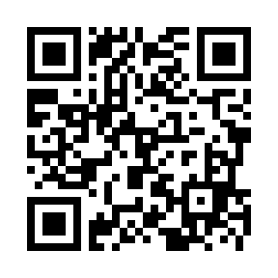 | ★ウェブサイト https://banksyexplained.com/napalm-2004/  バンクシーの『ナパーム』と、モチーフとなった写真『戦争の恐怖』を比べましょう。
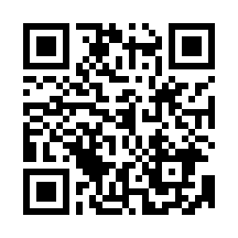 | ★動画 Julien's Auctions Banksy's Donkey Documents from the 2015 Street Art Auction  https://www.youtube.com/watch?v=zoPj1UUhM9U&t=69s  バンクシーの『ロバと兵士』はオークションにかけられました。
★次の文を３回以上読んで、暗唱しましょう。
１．The incident happened just an hour after Banksy confirmed it was genuine by posting a photo on his Instagram account.
２．Many of his Instagram followers interpret the latest work as a call for a ceasefire in the Gaza strip.
３．He looks angry and aggressive in his posture, but he is not throwing a bomb. He is holding flowers, the universal symbol of love and peace, the opposite item of a weapon.
４．In Banksy’s work, the girl is in the center of two symbols of American commercialism, Micky Mouse and Ronald McDonald. They make us think about the dangers of wars and capitalism.
５．Some say Banksy could have helped Palestinians by donating money, or painting on the Israeli side of the wall.
- その出来事は、バンクシーが自身のインスタグラムのアカウントで写真を投稿し、それが本物だと証明をして一時間後に起こった。
- 多くの彼のInstaのフォロワーたちが、この最新の作品はガザ地区での停戦を呼びかけたものと解釈している。
- 彼の姿勢は、怒っていて攻撃的なように見えるが、彼は爆弾を投げているわけではない。彼が抱えているのは、世界共通の愛と平和の象徴である花だ。それは武器と反対のものだ。
- バンクシーの作品で、少女はアメリカの商業主義であるミッキーマウスとロナルド・マクドナルドの中央にいる。
この作品は私達に、戦争と資本主義の危険性について考えさせる。
- バンクシーは、お金を寄付したり、イスラエル側の壁に絵を描いたりすることによって、パレスチナ人を助けることが
できたはずだ、と言っている。 ※could have…の部分は「仮定法過去完了」

［Essay］
Do you think street art makes the community better? Why do you think so? Give two reasons.

